Khaleej Times News
- Digital Marketing:

Link: https://www.khaleejtimes.com/kt-network/why-digital-marketing-should-be-done-in-house
- Data scientist:

Link: https://www.khaleejtimes.com/kt-network/data-science-continues-to-be-a-rising-career-in-the-years-to-come

- Cyber security:

Link: https://www.khaleejtimes.com/local-business/uae-jobs-with-up-to-dh55000-salary-cybersecurity-experts-in-demand

- Software engineer:
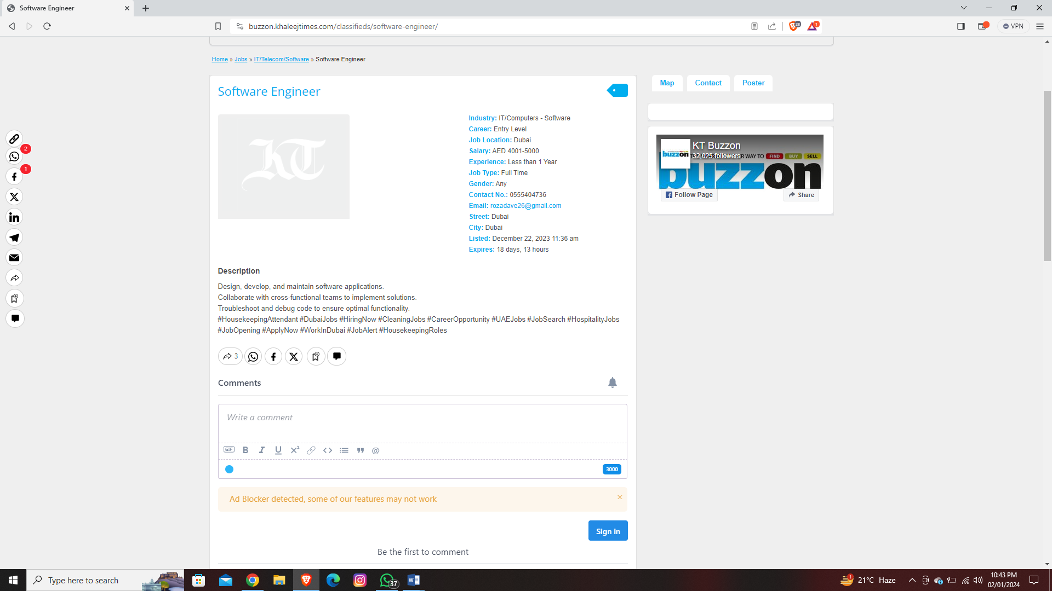
Link: https://buzzon.khaleejtimes.com/classifieds/software-engineer/

INDEED

1) Junior Software Engineer:

https://pk.indeed.com/viewjob?cmp=Riksof-Private-Limited&t=Engineer&jk=455026db415a3368&q=junior+software+engineer&xpse=SoD867I3Glq95xgIrD0LbzkdCdPP&xkcb=SoDX67M3GlqmpEQI3x0KbzkdCdPP&vjs=3
2) Digital Marketing:

https://pk.indeed.com/viewjob?cmp=FRYPI-DIGITAL&t=Digital+Marketer&jk=77cc2fafddea90cc&q=digital+marketing&xpse=SoDn67I3GlrBsSwHGp0LbzkdCdPP&xkcb=SoAl67M3GlrHUZwI3x0DbzkdCdPP&vjs=3

3) Network administrator:

https://pk.indeed.com/viewjob?cmp=Call-Courier-Pvt-Ltd-Company&t=Network+Administrator&jk=44019730dc2f174d&q=network+administrator&xpse=SoCM67I3Glr7EQSnT50LbzkdCdPP&xkcb=SoCY67M3Glr89_SFgx0LbzkdCdPP&vjs=3

4) Data Scientist:

https://pk.indeed.com/viewjob?cmp=RTW-Creation&t=Data+Scientist&jk=d7c2678ee1cb6dc2&q=data+scientist&xpse=SoCg67I3GlssNRR_hJ0LbzkdCdPP&xkcb=SoDP67M3GlsQpxxr8h0JbzkdCdPP&vjs=3

5) Cyber security:

https://pk.indeed.com/viewjob?jk=efb3cf68dfc6bf36&tk=1hj5ier4akcph800&from=serp&vjs=3

6) Web development manager:

https://pk.indeed.com/viewjob?cmp=Reading-Metro-Transportation&t=Web+Developer&jk=72ab2c01a14a8003&q=Web+development&xpse=SoDY67I3GltfuowI9p0LbzkdCdPP&xkcb=SoD567M3GltBWFQFkx0LbzkdCdPP&vjs=3

7) Artificial intelligence :

https://pk.indeed.com/viewjob?cmp=Appedology-PVT-Ltd.&t=Business+Intelligence+Developer&jk=b20881202a00847c&q=Artificial+intelligence&xpse=SoDp67I3Glts_HwHq50LbzkdCdPP&xkcb=SoBM67M3GltvJTwsV50PbzkdCdPP&vjs=3

8) Social media:

https://pk.indeed.com/viewjob?cmp=AKsons-Digital&t=Social+Media+Specialist&jk=777f69687d19f65d&xpse=SoD167I3Glt0Yqx_gJ0LbzkdCdPP&xkcb=SoCP67M3Glt1rwSFgx0LbzkdCdPP&vjs=3

